# ADO 15893 - BBR- NEW YORK FREE TRADE ZONE DISCLOSURE is missing in NY quote letter

Steps-

Create a NY state quote

Save and generate the Quote letter

Actual Result-

In the Quote letter, ‘NEW YORK FREE TRADE ZONE DISCLOSURE’ is missing

Screenshots-

Expected Result-

‘NEW YORK FREE TRADE ZONE DISCLOSURE’ should be available only for NY state quote letter

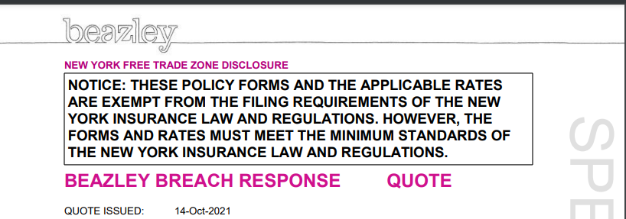

Test Results:

A new Quote for New York was created in AP-BBR

Then, the quote was opened in UWP, selected the Quote Letter and searched for the word ‘**NEW YORK FREE TRADE ZONE DISCLOSURE**’, but this is not in the document.

